Use Assignment 3

Please use the following VISSIM network.

PTV VISSIM 2021\Tutorials & Guides\Tutorial First Steps\VISSIM Files\Headquarters 10.inpx

C:\Users\Public\Documents\PTV Vision\PTV Vissim 2021\Tutorials & Guides\Tutorial First Steps\Vissim Files

1. Please show the following required operations: links, desired speed decisions, reduced speed areas, conflict areas, priority rules (if any), detectors, vehicle inputs, and vehicle routes. Upload snapshots containing any relevant information.

Please list the numbers of each types of modeling objects. Please use one sentence to describe the first object at each object type.

|  |  |  |  |
| --- | --- | --- | --- |
| Operation | Snapshot | Amount | First object |
| Links |  | 22 links | Link 1  1-lane urban street with length of  310 m |
| Desired Speed Decisions |  | 3 desired speed decisions | 30 km/hr for link 12 |
| Reduced Speed Areas |  | 8 reduced speed areas | Reduced speed area for link 10,005 with the following criteria:  Car-25 km/hr Heavy Goods Vehicle-  20 km/hr  Bus-20 km/hr |
| Conflict Areas |  | 23 Conflict Areas | Conflict area for link 10,006 |
| Priority Rules | - | 0 Priority Rules | - |
| Detectors | - | 0 Detectors | - |
| Vehicle Inputs |  | 4 Vehicle Inputs (For Entering Directions) | 600 entering vehicles on link 1 |
| Vehicle Routes | Static    Parking Lot | Static: 6  Partial Route: 0  Partial PT: 0  Parking Lot: 2  Dynamic: 0  Closure:0  Managed Lanes: 0 | Static: Static vehicles routes for link 14  Parking Lot: Vehicle route for Link 2 from parking lot 1 |

1. Please choose three paths defined by yourself and check their travel time measures.

The run the simulation and make sure the simulation is finished.

After that, go to “Evaluation” in the menu to “Result Lists” a “Vehicle Travel Time Result”, to show your result.

Vehicle Travel Time Measurements Selected

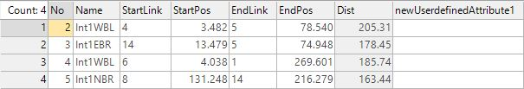

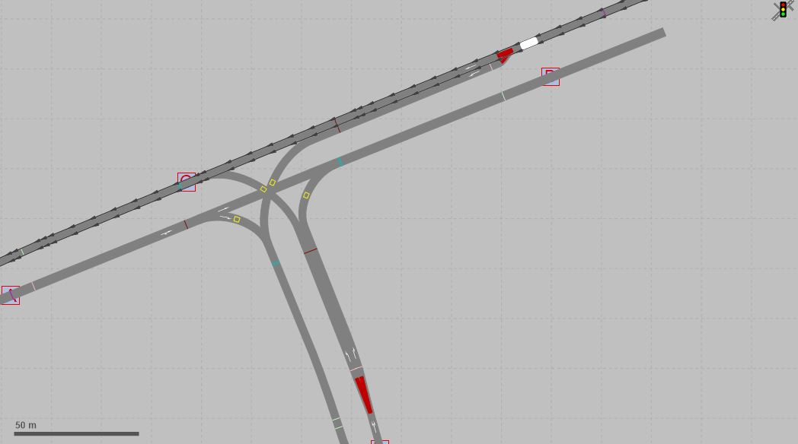

Vehicle Travel Time Results Output

|  |  |  |  |  |  |  |
| --- | --- | --- | --- | --- | --- | --- |
| Count | SimRun | TimeInt | VehicleTravel  TravelTime  Measurement | Vehs(All) | TravTime(All) | DistTrav(All) |
| 1 | 2 | 0-3600 | 1: Int1WBL | 128 | 13.88 | 60.25 |
| 2 | 2 | 0-3600 | 2: Int1EBR | 119 | 33.22 | 83.07 |
| 3 | 2 | 0-3600 | 3: Int1WBL | 472 | 12.60 | 140.67 |
| 4 | 2 | 0-3600 | 4: Int1NBR | 401 | 53.12 | 134.70 |
| 5 | 3 | 0-3600 | 1: Int1WBL | 128 | 13.88 | 60.25 |
| 6 | 3 | 0-3600 | 2: Int1EBR | 119 | 33.22 | 83.07 |
| 7 | 3 | 0-3600 | 3: Int1WBL | 472 | 12.60 | 140.67 |
| 8 | 3 | 0-3600 | 4: Int1NBR | 401 | 53.12 | 134.70 |
| 9 | Average | 0-3600 | 1: Int1WBL | 128 | 13.88 | 60.25 |
| 10 | Average | 0-3600 | 2: Int1EBR | 119 | 33.22 | 83.07 |
| 11 | Average | 0-3600 | 3: Int1WBL | 472 | 12.60 | 140.67 |
| 12 | Average | 0-3600 | 4: Int1NBR | 401 | 53.12 | 134.70 |
| 13 | Standard deviation | 0-3600 | 1: Int1WBL | 0 | 13.88 | 60.25 |
| 14 | Standard deviation | 0-3600 | 2: Int1EBR | 0 | 33.22 | 83.07 |
| 15 | Standard deviation | 0-3600 | 3: Int1WBL | 0 | 12.60 | 140.67 |
| 16 | Standard deviation | 0-3600 | 4: Int1NBR | 0 | 53.12 | 134.70 |
| 17 | Minimum | 0-3600 | 1: Int1WBL | 128 | 13.88 | 60.25 |
| 18 | Minimum | 0-3600 | 2: Int1EBR | 119 | 33.22 | 83.07 |
| 19 | Minimum | 0-3600 | 3: Int1WBL | 472 | 12.60 | 140.67 |
| 20 | Minimum | 0-3600 | 4: Int1NBR | 401 | 53.12 | 134.70 |